**National Institute of Technology, Raipur**

**Department of Computer Science and Engineering**



**Computer Network Lab - Practical Work**

**COURSE:** B.Tech.

**SEMESTER**: IV

**NAME:** KUNAL SACHDEVA

**ROLL NO. :** 19115045

**FACULTY IN-CHARGE:** Ms. Rakhi Seth

**No OF EXPERIMENTS:** 20

**INDEX**

|  |  |  |  |  |  |
| --- | --- | --- | --- | --- | --- |
| **S.No.** | **Date of Experiment** | **Name of Experiment** | **Page No.** | **Date of Submission** | **Remarks** |
| 1 |  | Introduction to Local Area Network with its cables, connectors and topologies. | 3 | 21-04-2021 |  |
| 2 |  | Installation of Switch. Hub their cascading and network mapping. | 5 | 21-04-2021 |  |
| 3 |  | Installation of UTP, Co-axial cable, Cross cable, parallel cable NIC and LAN card. | 7 | 21-04-2021 |  |
| 4 |  | Case Study of Ethernet (10 base 5,10 base 2,10 base T) | 9 | 21-04-2021 |  |
| 5 |  | Installation and working of Net meeting and Remote Desktop. | 11 | 21-04-2021 |  |
| 6 |  | Installation and working with Telnet (Terminal Network). | 14 | 21-04-2021 |  |
| 7 |  | Installation and working with FTP (File Transfer Protocol). | 16 | 21-04-2021 |  |
| 8 |  | Installation and Computers via serial or Parallel ports and enable the computers to share disk and printer port. | 19 | 21-04-2021 |  |
| 9 |  | Installation of NS-2/3 Network Simulator: Basics of Network Simulation | 20 | 21-04-2021 |  |
| 10 |  | Simulating a Local Area Network and LAN topologies. | 21 | 21-04-2021 |  |
| 11 |  | Implementation of various MAC protocol. | 25 | 21-04-2021 |  |
| 12 |  | Measuring Network Performance: Network Performance Evaluation, Performance Evaluation Metrics. | 29 | 21-04-2021 |  |
| 13 |  | Performance Evaluation of routing Protocol. | 31 | 21-04-2021 |  |
| 14 |  | Parameter Affecting the Performance of Network, Performance Evaluation Technique, Network Performance Evaluation using NS-2/3 | 34 | 21-04-2021 |  |
| 15 |  | Implement an Ethernet LAN using n nodes and set multiple traffic nodes and plot congestion window for different source / destination. | 34 | 21-04-2021 |  |
| 16 |  | Implement simple ESS and with transmitting nodes in wire-less LAN by simulation and determine the performance with respect to transmission of packets. | 37 | 21-04-2021 |  |
| 17 |  | Write a program for error detecting code using CRC-CCIT(16- bits) | 41 | 21-04-2021 |  |
| 18 |  | Write a program to find the shortest path between vertices using bellman-ford algorithm. | 45 | 21-04-2021 |  |
| 19 |  | Write a program for simple RSA algorithm to encrypt and decrypt the data. | 48 | 21-04-2021 |  |
| 20 |  | Write a program for congestion control using leaky bucket algorithm. | 51 | 21-04-2021 |  |

**EXPERIMENT 1**

**Aim:** Introduction to Local Area Network with its cables, connectors and topologies

**Topologies:**

Four LAN topologies exist:

1. Star (Hub-and-Spoke)
2. Ring
3. Bus
4. Tree

Star (Hub-and-Spoke) Topology

All stations are attached by cable to a central point, usually a wiring hub or other device operating in a similar function.

Ring Topology

All stations in a ring topology are considered repeaters and are enclosed in a loop. Unlike the star (hub-and-spoke) topology, a ring topology has no end points.

Bus Topology

Sometimes referred to as linear-bus topology, Bus is a simple design that utilizes a single length of cable, also known as the medium, with directly attached LAN stations. All stations share this cable segment. Every station on this segment sees transmissions from every other station on the cable segment; this is known as a broadcast medium.

Tree Topology

The tree topology is a logical extension of the bus topology and could be described as multiple interconnected bus networks. The physical (cable) plant is known as a branching tree with all stations attached to it. The tree begins at the root, the pinnacle point, and expands to the network endpoints. This topology allows a network to expand dynamically with only one active data path between any two network endpoints.

**Connectors:**

Type of network cable connector (such as Rj-45, J Rj-11, USB, MT-RJ, Coaxial BNC, LC Local Connector, MT-RJ, USB BNC and AUI) is used to connect what type of network cable.

USB (Universal Serial Bus)

* Universal Serial Bus, or USB, is a computer standard designed to eliminate the guesswork in connecting peripherals to a PC. It is expected to replace serial and parallel ports. A single USB port can be used to connect up to 127 peripheral devices, such as mice, modems, keyboards, digital camera's, printers, scanners, MP3 players and many more. USB also supports Plug-and-Play installation and hot plugging.
* USB 1.1 standard supports data transfer rates of 12 Mbps.
* USB 2.0 (Also referred to as Hi-Speed USB) specification defines a new High-speed transfer rate of 480 Mb/sec.
* USB 2.0 is fully compatible with USB 1.1 and uses the same cables and connectors. USB has with two connector types. The first is Type A (on the right), This connector connects to the PC's USB port. The Type B (on the left) connector and is for connecting to the relevant peripheral. Whereas the type A connector is truly standard, the Type B connector could be changed in size etc. with individual peripherals meaning they require their own unique cables.

RJ-11 (Registered Jack)

Standard telephone cable connectors, RJ-11 has 4 wires (and RJ-12 has wires). RJ-11 is the acronym for Registered Jack-11, a four- or six-wire connector primarily used to connect telephone equipment.

RJ-45 (Registered Jack)

The acronym for Registered Jack-45 is RJ-45. The RJ-45 connector is an eight-wire connector that is commonly used to connect computers to a local area network (LAN), particularly Ethernet LANs. Although they are slightly larger than the more commonly used RJ-11 connectors,RJ-45s can be used to connect some types of telephone equipment.

F-Type

The F connector is a type of RF connector commonly used for cable and universally for satellite television. They are also used for the cable TV connection in DOCSIS cable modems, usually with RG-6 tri-shield cable. The F connector is inexpensive, yet has good performance up to 1 GHz. One reason for its low cost is that it uses the centre wire of the coaxial cable as the pin of the male connector. The male connector body is typically crimped onto the exposed outer braid. Female connectors have a 3/8-32 thread. Most male connectors have a matching threaded connecting ring, though push-on versions are also available.

MT-RJ (Mechanical Transfer Registered Jack)

* MT-RJ connectors are used with single-mode and multimode fiber-optic cables. The MT-RJ connectors are constructed with a plastic housing and provide for accurate alignment via their metal guide pins and plastic ferrules.
* Used for Gigabit ethernet. To connect to modules with MT-RJ interfaces, use multimode fiber-optic cables.

**Cables:**

To connect two or more computers or networking devices in a network, network cables are used. There are three types of network cables; coaxial, twisted-pair, and fiber-optic.

Coaxial cable

* This cable contains a conductor, insulator, braiding, and sheath. The sheath covers the braiding, braiding covers the insulation, and the insulation covers the conductor.

Twisted-pair cables

* The twisted-pair cable was primarily developed for computer networks. This cable is also known as Ethernet cable. Almost all modern LAN computer networks use thiscable.
* This cable consists of color-coded pairs of insulated copper wires. Every two wires are twisted around each other to form pair. Usually, there are four pairs. Each pair has one solid color and one stripped color wire. Solid colors are blue, brown, green and orange. In stripped color, the solid color is mixed with the white color.
* Based on how pairs are stripped in the plastic sheath, there are two types of twisted-pair cable; UTP and STP.
* In the UTP (Unshielded twisted-pair) cable, all pairs are wrapped in a single plastic sheath.
* In the STP (Shielded twisted-pair) cable, each pair is wrapped with an additional metal shield, then all pairs are wrapped in a single outer plastic sheath.

Fiber optic cable

* This cable consists of core, cladding, buffer, and jacket. The core is made from the thin strands ofglass or plastic that can carry data over the long distance. The core is wrapped in the cladding; the cladding is wrapped in the buffer, and the buffer is wrapped in the jacket.
* Core carries the data signals in the form of the light.
* Cladding reflects light back to the core.
* Buffer protects the light from leaking.
* The jacket protects the cable from physical damage.
* Fiber optic cable is completely immune to EMI and RFI. This cable can transmit data over a long distance at the highest speed. It can transmit data up to 40 kilometers at the speed of 100Gbps.
* Fiber optic uses light to send data. It reflects light from one endpoint to another. Based on how many beams of light are transmitted at a given time, there are two types of fiber optical cable; SMF and MMF.

**EXPERIMENT 2**

**Aim:** Installation of Switch. Hub their cascading and network mapping.

**Hubs:**

A hub is basically a multiport repeater. A hub connects multiple wires coming from different branches, for example, the connector in star topology which connects different stations. Hubs cannot filter data, so data packets are sent to all connected devices. In other words, collision domain of all hosts connected through Hub remains one. Also, they do not have the intelligence to find out best path for data packets which leads to inefficiencies and wastage.

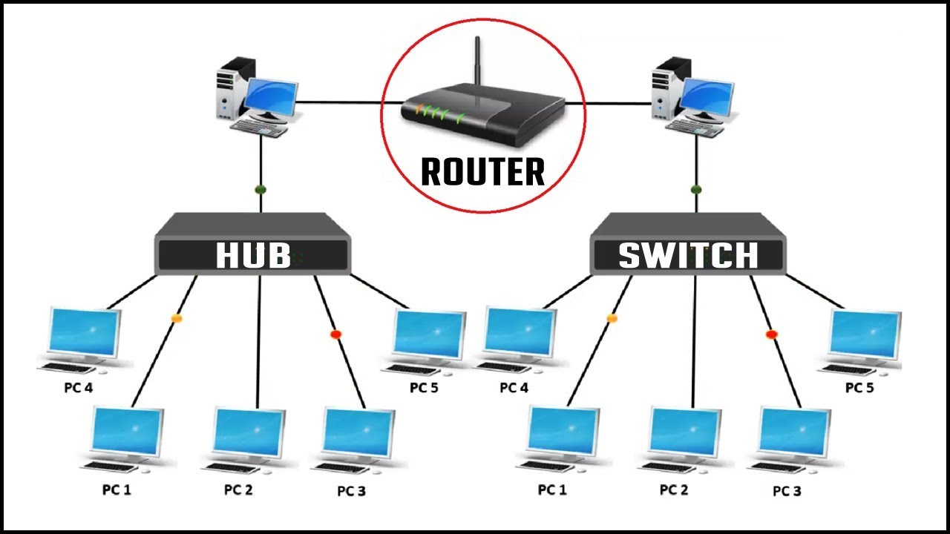

**Switches:**

A switch is a multiport bridge with a buffer and a design that can boost its efficiency(a large number of ports imply less traffic) and performance. A switch is a data link layer device. The switch can perform error checking before forwarding data, that makes it very efficient as it does not forward packets that have errors and forward good packets selectively to correct port only. In other words, switch divides collision domain of hosts, but broadcast domain remains same.

**Installing Switch:**

* Connect devices via LAN cable with the hub/switch.
* Assign IP addresses(IP Config).
* Check Connectivity(Ping ip_address).

**Routers:**

* A router is a networking device that forwards data packets between computer networks. Routers perform the traffic directing functions on the Internet. Data sent through the internet, such as a web page or email, is in the form of data packets. A packet is typically forwarded from one router to another router through the networks that constitute an internetwork until it reaches its destination node.

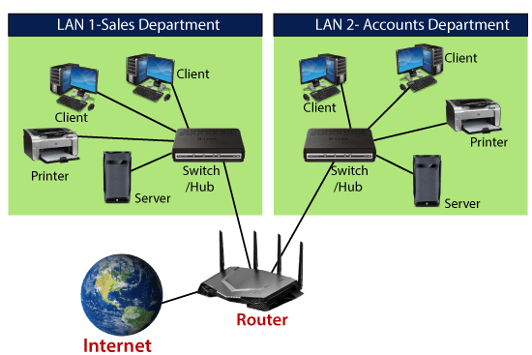

* A router is connected to two or more data lines from different IP networks. When a data packet comes in on one of the lines, the router reads the network address information in the packet header to determine the ultimate destination. Then, using information in its routing table or routing policy, it directs the packet to the next network on its journey.

**EXPERIMENT 3**

**Aim:** Installation of UTP, Co-axial cable, Cross cable, parallel cable NIC and LAN card.

**UTP cable:**

* UTP stands for Unshielded Twisted Pair cable. UTP cable is a 100 ohm copper cable that consists of 2 to 1800 unshielded twisted pairs surrounded by an outer jacket.
* They have no metallic shield. This makes the cable small in diameter but unprotected against electrical interference. The twist helps to improve its immunity to electrical noise and EMI.
* UTP cables are mostly used for LAN networks. They can be used for voice, low-speed data, high-speed data, audio and paging systems, and building automation and control systems. UTP cable can be used in both the horizontal and backbone cabling subsystems.

Commonly used types of UTP cabling are as follows:

1. Category 1—Used for telephone communications. Not suitable for transmitting data.
2. Category 2—Capable of transmitting data at speeds up to 4 megabits per second (Mbps).
3. Category 3—Used in 10BASE-T networks. Can transmit data at speeds up to 10 Mbps.
4. Category 4—Used in Token Ring networks. Can transmit data at speeds up to 16 Mbps.
5. Category 5—Can transmit data at speeds up to 100 Mbps.
6. Category 5e —Used in networks running at speeds up to 1000 Mbps (1 gigabit per second [Gbps]).
7. Category 6—Typically, Category 6 cable consists of four pairs of 24 American Wire Gauge (AWG) copper wires. Category 6 cable is currently the fastest standard for UTP.

UTP cable often is installed using a Registered Jack 45 (RJ-45) connector. The RJ-45 is an eight-wire connector used commonly to connect computers onto a local-area network (LAN), especially Ethernets. RJ45 connectors feature eight pins to which the wire strands of a cable interface electrically. Standard RJ-45 pinouts define the arrangement of the individual wires needed when attaching connectors to a cable.

**Coaxial Cable:**

Coaxial cables, commonly called coax, are copper cables with metal shielding designed to provide immunity against noise and greate bandwidth. Coax can transmit signals over larger distances at a higher speed as compared to twisted pair cables.

Structure of Coaxial Cables

Coax has a central core of stiff copper conductor for transmitting signals. This is covered by an insulating material. The insulator is encased by a closely woven braided metal outer conductor that acts as a shield against noise. The outer conductor is again enclosed by a plastic insulating cover.

Applications of Coaxial Cables

* In analog telephone networks: A single coaxial network cancarry about 10,000 voice signals.
* In digital telephone networks: A coax has a data rate of 600 Mbps.
* In cable TV networks
* In traditional Ethernet LANs
* In MANs

**Ethernet cross-over cable:**

In this cable, transmitting pins of one side connect with the receiving pins of the other side.

The wire at pin 1 on one end of the cable connects to pin 3 at the other end of the cable. The wire at pin 2 connects to pin 6 on the other end of the cable. Remaining wires connect in the same positions at both ends.

The cross-over cable is used to connect the following devices.

* Two computers
* Two hubs
* A hub to a switch
* A cable modem to a router
* Two router interfaces

**Network Interface Card (NIC):**

Network Interface Card (NIC) is a hardware component that is present on the computer. It is used to connect different networking devices such as computers and servers to share data over the connected network. It provides functionality such as support for I/O interrupt, Direct Memory Access (DMA) interfaces, partitioning, and data transmission.

A list of functions of the Network Interface Card is given below -

* NIC is used to convert data into a digital signal.
* In the OSI model, NIC uses the physical layer to transmit signals and the network layer to transmit data packets.
* NIC offers both wired (using cables) and wireless (using Wi-Fi) data communication techniques.
* NIC is a middleware between a computer/server and a data network.
* NIC operates on both physical as well as the data link layer of the OSI model.

**EXPERIMENT 4**

**Aim:** Case Study of Ethernet (10 base 5,10 base 2,10 base T)

Ethernet is a family of frame-based computer networking technologies for local area networks (LANs). The name comes from the physical concept of the ether. It defines a number of wiring and signalling standards for the physical layer, through means of network access at the Media Access Control(MAC)/Data Link Layer, and a common addressing format.

**10BASE2**

10BASE2 (also known as cheapernet, thin ethernet, thinnet or thinwire) is a variant of Ethernet that uses thin coaxial cable (RG-58 or similar, as opposed to the thicker RG-8cable used in 10BASE5 networks), terminated with BNC connectors For many years this was the dominant 10 Mbit/s Ethernet standard, but due to the immense demand for high speed networking, the low cost of Category 5 Ethernet cable, and the popularity of 802.11 wireless networks, both 10BASE2 and 10BASE5 have become almost obsolete.

Network design

In a 10BASE2 network, each segment of cable is connected to the transceiver(which is usually built into the network adaptor) using a BNC T-connector, with one segment connected to each arm of the T. At the physical end of the network a 50 Ohm terminator is required. This is most commonly connected directly to the T-connector on a workstation though it does not technically have to be. A failure at any point of the network cabling tends to prevent all communications. For this reason, 10BASE2 networks could be difficult to maintain and were often replaced by 10BASE-T networks, which (provided category 3 cable or better was used) also provided a good upgrade path to 100BASE-TX. An alternative reliable connection has been established by the introduction of EAD-sockets.

**Comparisons to 10BASE-T**

10BASE2 networks cannot generally be extended without breaking service temporarily for existing users and the presence of many joints in the cable also makes them very vulnerable to accidental or malicious disruption. There were proprietary wallport/cable systems that claimed to avoid these problems (e.g. SaferTap) but these never became widespread, possibly due to a lack of standardization.

10BASE2 systems do have a number of advantages over 10BASE-T. They do not need the 10BASET hub, so the hardware cost is very cheap, and wiring can be particularly easy since only a single wire run is needed, which can be sourced from the nearest computer. These characteristics mean that 10BASE2 is ideal for a small network of two or three machines, perhaps in a home where easily concealed wiring may be an advantage.

**10BASE5**

10BASE5 (also known as thicknet) is the original "full spec" variant of Ethernet cable, using special cable similar to RG-8/U coaxial cable. This is a stiff, 0.375 inch (approx. 9.5 mm) diameter cable with an impedance of 50 ohms, a solid center conductor, a foam insulating filler, a shielding braid, and an outer jacket. The outer sheath is often yellow-to-orange/brown foam fluorinated ethylene propylene (for fire resistance) so it frequently is just called "yellow cable", "orange hose", or sometimes humorously "frozen yellow garden hose". 10BASE5 is obsolete, though due to its widespread deployment in the early days, some systems may still be in use.

Network design

10BASE5 cable is designed to allow transceivers to be added while existing connections are live. This is achieved using a vampire tap - a device which (with sufficient practice) clamps onto the cable, forcing a spike to pierce through the outer shielding to contact the inner conductor while other spikes bite into the outer conductor. This is often built into the transceiver and a more flexible multi-wire cable carries the connection between the transceiver and the node. Transceivers can also be connected by using N connectors at the end of a cable segment.

**Ethernet over twisted pair(10 BASE T)**

There are several standards for Ethernet over twisted pair or copper-based computer networking physical connectivity methods. The currently most widely used of these are 10BASE-T, 100BASETX, and 1000BASE-T(Gigabit Ethernet), running at 10 Mbit/s, 100 Mbit/s, and 1000 Mbit/s (1 Gbit/s) respectively. These three standards all use the same connectors. Higher speed implementations nearly always support the lower speeds as well, so that in most cases different generations of equipment can be freely mixed. They use 8 position modular connectors, usually (but incorrectly) called RJ45 in the context of Ethernet over twisted pair.

The common names of the standards are derived from several aspects of the physical media. The number refers to the theoretical maximum transmission speed in Megabits per second (Mbit/s). The BASE is short for baseband, meaning that there is no frequency division multiplexing (FDM) or other frequency shifting modulation in use; each signal has full control of wire, on a single frequency.

**Cabling**

Twisted-pair Ethernet standards are such that the majority of cables can be wired 'straight-through' (pin 1 to pin 1, pin 2 to pin 2 and so on), but others may need to be wired in the 'crossover' form (receive to transmit and transmit to receive).

10BASE-T and 100BASE-TX only require two pairs to operate, pins 1 and 2 (transmit or TX), and pins 3 and 6 (receive or RX). Since 10BASE-T and 100BASE-TX need only two pairs and Category 5 cable has four pairs, it is possible, but not standard, to run two network connections (or a network connection and two phone lines) over a cat 5cable by using the normally unused pairs in these 10 and 100 Mbit/s configurations. This is not possible with 1000BASE-T since it requires all four pairs to operate, pins 1 and 2, 3 and 6 — as well as 4 and 5, 7 and 8.

It is conventional to wire cables for 10 or 100 Mbit/s Ethernet to either the T568A or T568B standards. Since these standards only differ in that they swap the positions of the two pairs used for transmitting and receiving (TX/RX), a cable with TIA-568A wiring at one end and TIA-568B wiring at the other will be a crossover cable. The terms used in the explanations of the 568 standards, tip and ring, refer to older communication technologies, and equate to the positive and negative parts of the connections.

Unlike earlier Ethernet standards using broadband and coaxial cable, such as 10BASE5 (thicknet) and 10BASE2 (thinnet), 10BASE-T does not specify the exact type of wiring to be used but instead specifies certain "characteristics" which a cable must meet. This was done in anticipation of using 10BASE-T in existing twisted pair wiring systems that may not conform to any specified wiring standard. Some of the specified characteristics are attenuation, characteristic impedance, timing jitter, propagation delay, and several types of noise. Cable testers are widely available to check these parameters to determine if a cable can be used with 10BASE-T. These characteristics are expected to be met by 100 meters of 24 gauge unshielded twisted-pair cable, and 100 meters is the stated maximum length for baseband signal runs. However, with high quality cabling, cable runs of 150 meters or longer are often obtained and are considered viable by most technicians familiar with the 10baseT specification, though -- as with all CSMA/CD network environments — the absolute limit on run length is determined by the size of the collision domain and cable quality. In reality, what meets the standards may not work, and those that don't meet the standards might work.

**EXPERIMENT 5**

**Aim:** Installation and working of Net meeting and Remote Desktop

Remote administration tools help IT professionals to debug remotely. You can perform computer maintenance related tasks remotely. There are a plethora of remote software tools in the market: NetMeeting, Team Viewer, AnyDesk, etc.

Microsoft Windows NetMeeting is a tool for real-time PC-to-PC screen sharing and for remote control of Windows PC's across the network. It can be used in parallel with the main video conferencing system so that any site that has connected to the NetMeeting session can share a computer display or application with all of the other sites.NetMeeting was a popular instant messaging (IM) application that was included with Microsoft Windows versions 95 OSR2 to Windows XP.

**Installing NetMeeting**

You can download the NetMeeting installation is straightforward, but you must decide whether you want to log on to a directory server when NetMeeting starts.

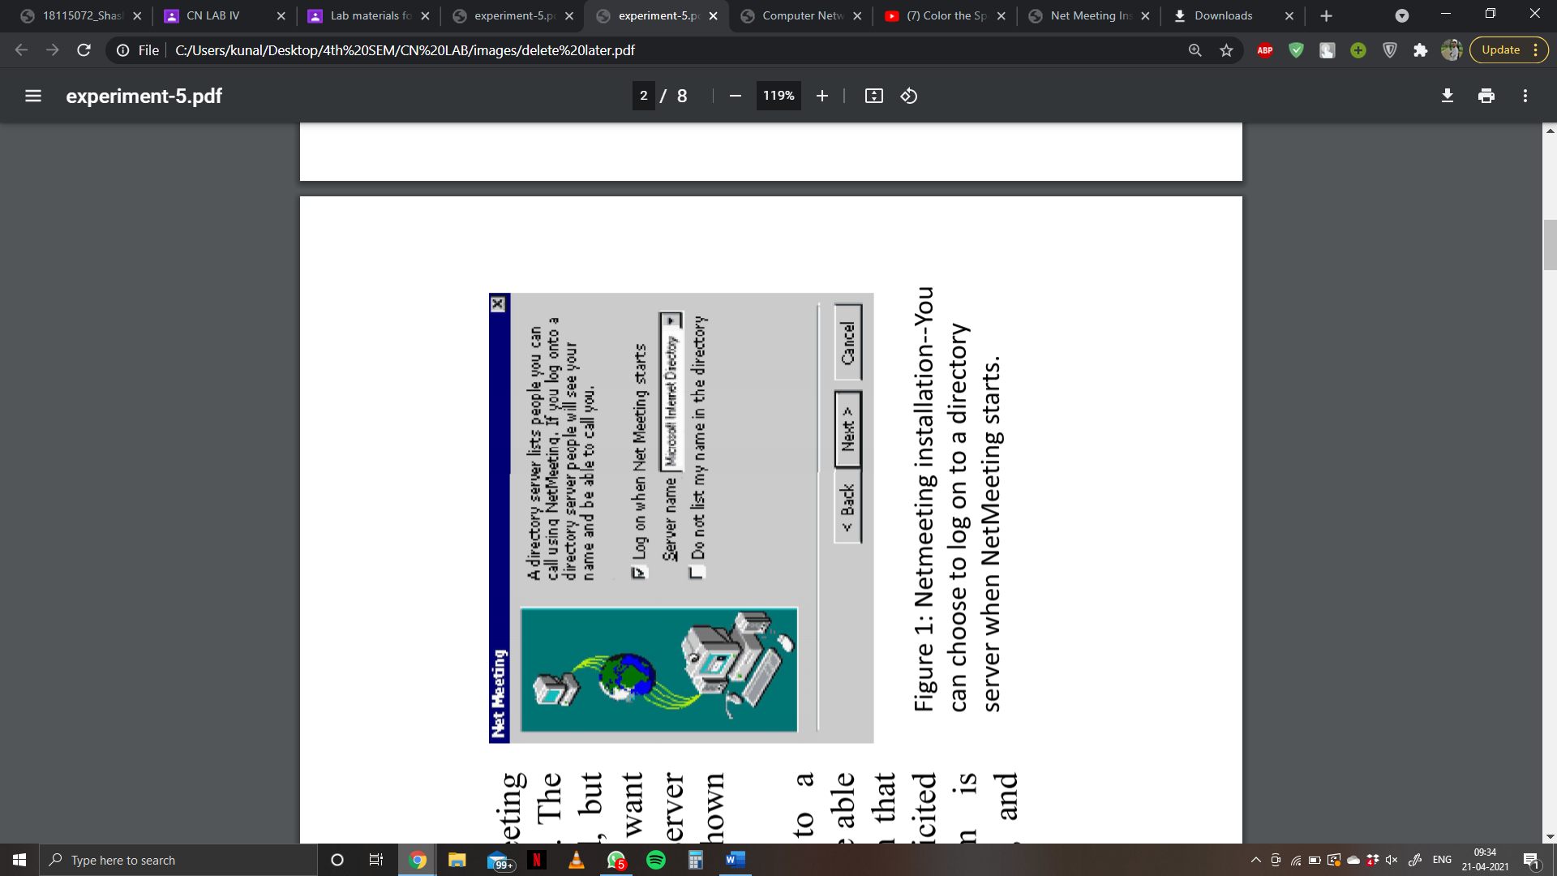If you choose to log on to a directory server, others will be able to see your name--a situation that may open the door to unsolicited callers. Once the program is installed, you can launch it, and finish the configuration.

**Activating remote desktop sharing**

Before you can use Remote Desktop Sharing, you must activate it in NetMeeting. Remote Desktop Sharing will not work if NetMeeting is running on the computer. To set up Remote Desktop Sharing, do the following:

1. Launch NetMeeting.
2. Choose Tools Enable Sharing and follow the instructions on screen.
3. Reboot your computer.
4. After your computer restarts, launch NetMeeting.
5. Choose Tools Remote Desktop Sharing and follow the instructions on screen. I highly recommend that you enable a password-protected screen saver when prompted.
6. Close NetMeeting.

**Running a remote session**

To access a computer remotely using NetMeeting, do the following:

1. Launch NetMeeting.
2. Click the Place Call button. The dialog box will open. On the To line, type the computer name or IP address of the remote computer. If the Require Security for This Call check box isn't selected, you must click it to turn on security.

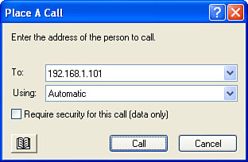

**AnyDesk**

AnyDesk is remote desktop software that you can run portably or install like a regular program. This remote desktop tool helps you to ensures secure remote desktop connections for IT professionals.

Features:

* Supports audio and file transfer.
* This rdp software Helps you to record the remote session.
* Connections can be configured to favour quality or speed.
* Automatically update to new software versions.
* 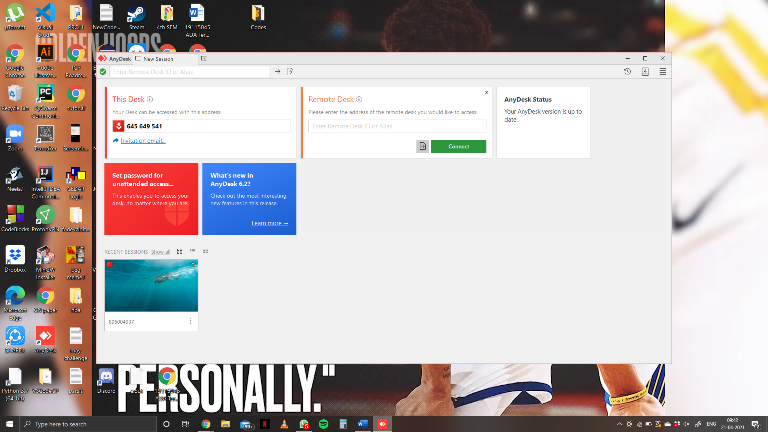Works on Linux, Windows, and macOS.

**Team Viewer**

Team Viewer remote desktop software. It allows you to connect to multiple workstations remotely. It helps you to enhance remote control performance with GPU for hardware accelerated image processing.

Features:

* Allows you to pass the control from one person to person.
* Easy & Secure Remote Desktop Access.
* This remote desktop software for windows Support Augmented reality.
* You can include multiple parties in connection.
* 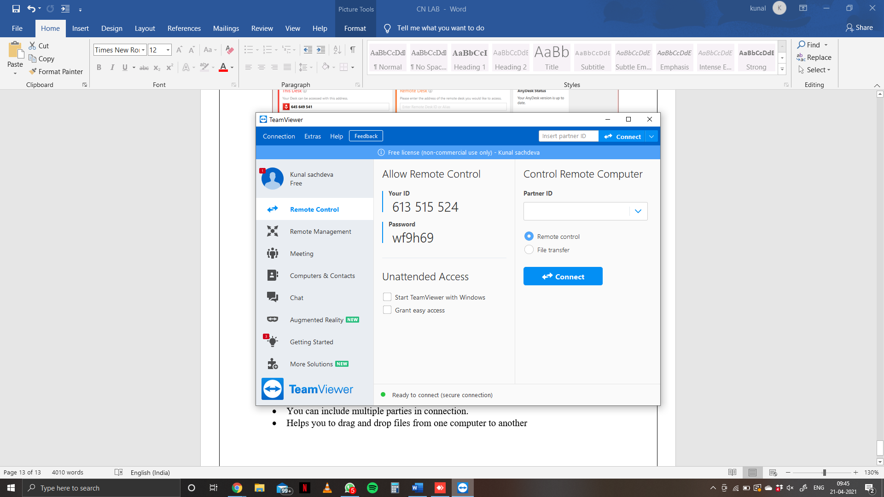Helps you to drag and drop files from one computer to another.

**EXPERIMENT 6**

**Aim:** Installation and working with Telnet (Terminal Network)

**Telnet**

* A popular client-server program Telnet is used to provide a general client-server program that lets the user access any application program on a remote computer.
* Telnet is an abbreviation for Terminal Network.
* 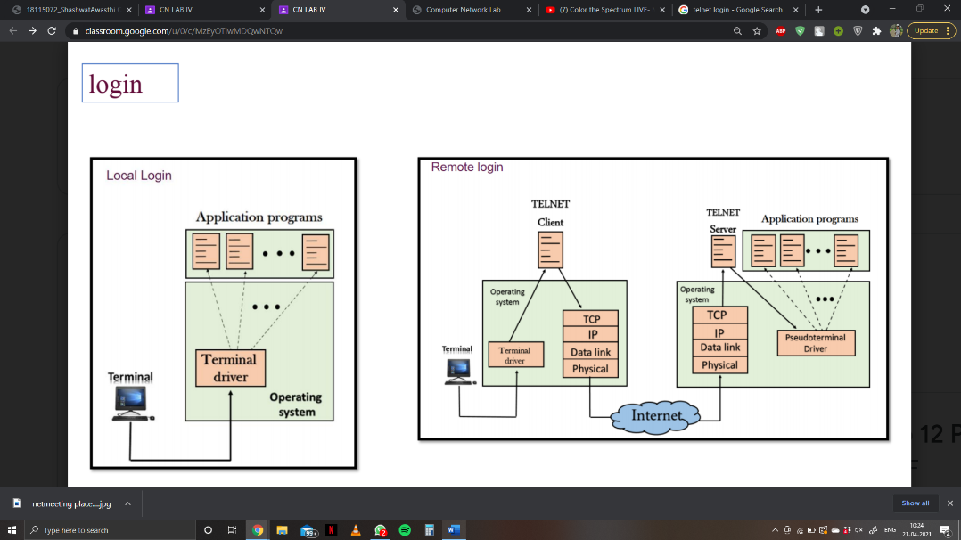Telnet provides a connection to the remote computer in such a way that a local terminal appears to be at the remote side.

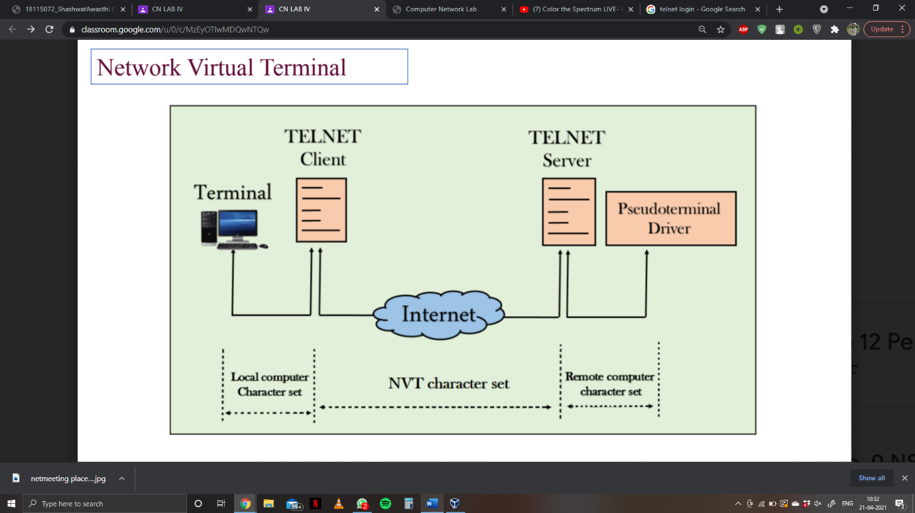

**Install Telnet on Windows**

Telnet is not installed by default on Windows; if you try to run it you will get the message “‘Telnet’ is not recognized as an operable program or batch file.” To install Telnet:

1. Click Start.
2. Select Control Panel.
3. Choose Programs and Features.
4. Click Turn Windows features on or off.
5. Select the Telnet Client option.
6. Click OK.
7. A dialog box appears to confirm installation. The telnet command should now be available.

**Install Telnet on Linux**

It is installed by default on Linux and older Mac operating systems

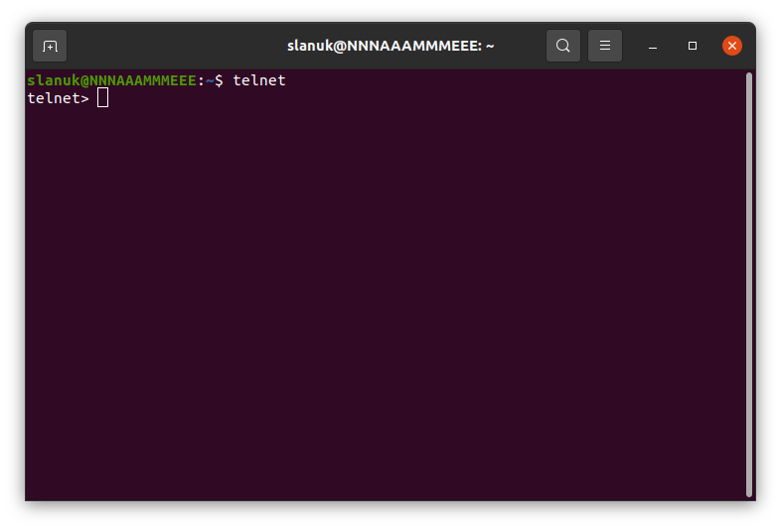Linux: Open Terminal

We can list all the commands by executing the help command, execute the help command by typing h. Consider the below output:

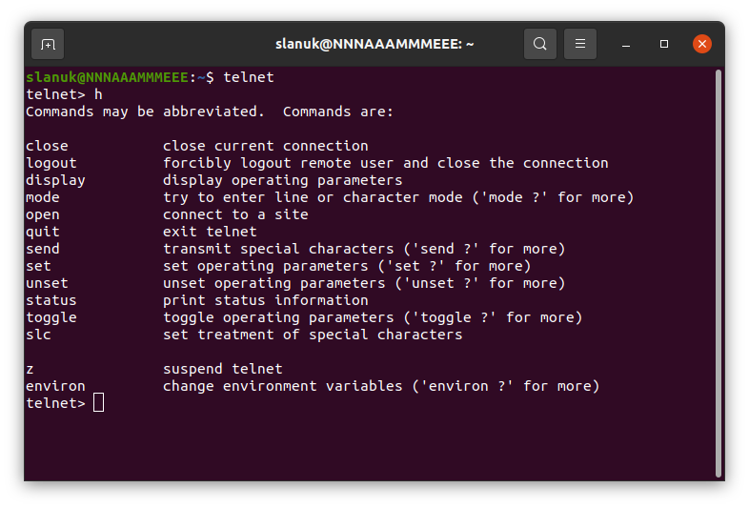

**Experiment No: 7**

**Aim:** Installation and working with FTP.

* Setting up a File Transfer Protocol (FTP) server on Windows 10 is perhaps one of the most convenient solutions to upload and download files from virtually anywhere to your computer without the limitations typically found with cloud storage services.
* Using an FTP server, you're basically creating a private cloud that you have absolute control. You don't have monthly transfers caps and speeds can be fast (depending on your internet subscription).
* Also, there not file type or size restrictions, which means that you can transfer a 1KB text file as well as 1TB backup file, and you can create as many accounts as you want to let family and friends store and share files with each other.
* There are plenty third-party solutions to set up a file server of this kind, but even though it may sound complicated, the FTP feature bundled on Windows 10 isn't difficult to set up.
* In this Windows 10 guide, we'll walk you through the steps to set up and manage an FTP server on your computer to transfer files within your home network or remotely over the internet.

**How to install the FTP server components on Windows 10**

* Although Windows 10 includes support to set up an FTP server, you need to add the required components manually.
* To install the FTP server components, do the following:
* Open Control Panel.
* Click on Programs.
* Under "Programs and Features," click the Turn Windows features on or off link.
* Expand the "Internet Information Services" feature, and expand the FTP server option.
* Check the FTP Extensibility and FTP Service options.
* Check the Web Management Tools option with the default selections, but making sure that the IIS Management Console option is checked.
* Click the OK button.
* Click the Close button.

**How to configure an FTP server site on Windows 10**

* After installing the required components, you can proceed to configure an FTP server on the computer, which involves creating a new FTP site, setting up firewall rules, and allowing external connections.
* Setting up an FTP site
* To set up an FTP site, do the following:
* Open Control Panel.
* Click on System and Security.
* Click on Administrative Tools.
* Double-click the Internet Information Services (IIS) Manager shortcut.
* On the "Connections" pane, right-click Sites, and select the Add FTP Site option.
* In the FTP site name, type a short descriptive name for the server.
* In the "Content Directory" section, under "Physical path," click the button on the right to locate the folder you want to use to store your FTP files.
* Click the Next button.
* Use the default Binding settings selections.
* Check the Start FTP site automatically option.
* In the "SSL" section, check the No SSLoption.
* Click the Next button.
* In the "Authentication" section, check the Basic option.
* In the "Authorization" section, use the drop-down menu, and select Specified users option.
* Type the email address of your Windows 10 account or local account name to allow yourself access to the FTP server.
* Check the Read and Write options.
* Click the Finish button.
* After completing the steps, the FTP site should now be operational on your computer.

**Configuring firewall rules**

* If you're running the built-in firewall on Windows 10, connections to the FTP server will be blocked by default until you manually allow the service through, using these steps:
* Open Windows Defender Security Centre.
* Click on Firewall & network protection.
* Click the Allow an app through firewall option.
* Click the Change settings button.
* Check the FTP Server option, as well as the options to allow Private and Public access.
* Once you've completed the steps, the FTP server should now be accessible from the local network.
* In the case that you're running third-party security software, make sure to check your vendor support website for more specific details on adding firewall rules.

**Allowing external connections**

* To make your FTP server reachable from the internet, you also need to open the Transmission Control Protocol/Internet Protocol (TCP/IP) port number 21 on your router.
* The instructions to forward a port will be different depending on the router, and even depending on the firmware version. In the steps below, we'll outline the general steps, but you may need to consult your manufacturer support website for specific details.
* To forward port 21 to allow FTP connections outside of the local network, do the following:
* Open Settings.
* Click on Network & Internet.
* Click on Status.
* Click the Change connections properties option.
* Make a note of the IPv4 DNS server address, which is the address of your router. Usually, it's private address in the 192.168.x.x range. For instance, 192.168.1.1 or 192.168.2.1.
* Open your default web browser.
* On the address bar enter the router's IP address (for example, 192.168.1.1) and press Enter.
* Sign-in with your router credentials.
* Open the Port Forwarding page. (Usually, these settings can be found under the WAN, NAT, or Advanced settings pages.)
* Add a new rule to forward incoming connections to the FTP server from the internet by including this information:
  + Service name: Type a descriptive name for the port forwarding rule.
  + Port range: 21.
  + Local IP:This is the FTP server IP address that the router will forward incoming connections. (This is your IPv4 address. See step No. 5.)
  + Local port:21.
  + Protocol:TCP.
* Click the add button.
* Click the Apply button to save the changes.
* After completing the steps, any incoming connection on port 21 will be forwarded to the FTP server to establish a networking session.

**Setting up a static IP address**

* If you're planning to transfer files over the internet in the regular basis, then it's recommended to configure a static IP address to prevent having to reconfigure your router in the future if your device's IP changes.
* Open Control Panel.
* Click on Network and Internet.
* Click on Network and Sharing Center.
* In the left pane, click the Change adapter settings option.
* Right-click the network adapter, and select the Properties option.
* Select the Internet Protocol Version 4 (TCP/IPv4) option.
* Click the Properties button.
* Select the Use the following IP address option.
* Specify the IP settings:
  + IP address: Specify a static network address for the computer. You should use an address outside of the DHCP server scope configured in your router to prevent conflicts. For instance, 192.168.1.200.
  + Subnet mask:In a home network, the address usually is 255.255.255.0.
  + Default gateway:This is usually the IP address of the router. For example, 192.168.1.1.
  + Preferred DNS server: Typically, this is also the IP address of your router.
* Click the OK button.
* Click the Close button.
* Once you've completed the steps, the IP configuration will no longer change, and it'll prevent potential connection problems in the future.

**EXPERIMENT 8**

**Aim:** Installation and Computers via serial or Parallel ports and enable the computers to share disk and printer port.

* A port is a point at which an external device (peripheral) attaches to the computer system. Ports allow data to be sent/retrieved from the external device. The most common type of ports are:

1. Serial port
2. parallel port

* Serial ports transmit data sequentially one bit at a time. Serial ports are usually 9-pin or 25-pin male connectors. They are also known as COM (communication) ports or RS323C ports.
* Parallel ports can send or receive 8 bits or 1 byte at a time. Parallel ports come in form of 25-pin female pins and are used to connect printer, scanner, external hard disk drive, etc.

**Adding a Network Printer to Your Windows Computer**

1. Click on the Start button, and then select Devices and Printers.
2. In the Devices and Printers window, click on Add a printer.
3. In the Add Printer window, click on the option Add a local printer.
4. Select Create a new port, and then select Standard TCP/IP Port from the drop-down menu. Click Next when you’re done.
5. Enter the IP address of your printer. Select the option Query the printer and automatically select the driver to use. Click Next when you’re done. Note: If the printer is not automatically detected, please select the Manufacturer and Driver.
6. Select the option Use the driver that is currently installed (recommended).
7. Enter a descriptive name for the printer in the text box next to Printer name. (In the example below, “Harris 2nd Floor Break Room” is entered as the printer name.)
8. Select the option Do not share this printer and then click Next.
9. If the printer was added successfully, you should see the following confirmation message. Click Print a test page to confirm that you can print to the printer.
10. Click Close in the following window.
11. Click Finish.
12. If you want, you can view the new printer listing by clicking the Start button and then clicking on Devices and Printers. You should see the entry for your printer. (In the example below, the entry for printer “Harris 2nd Floor Break Room” is shown.)

**EXPERIMENT 9**

**Aim:** Installation of NS-2/3 Network Simulator: Basics of Network Simulation.

NS2 stands for Network Simulator Version 2. It is an open-source event-driven simulator designed specifically for research in computer communication networks.

1. It is a discrete event simulator for networking research.
2. It provides substantial support to simulate bunch of protocols like TCP, FTP, UDP, https and DSR.
3. It simulates wired and wireless network.
4. It is primarily Unix based.
5. Uses TCL as its scripting language.

**Installing NS2**

1. Update and install prerequisites packages

Using these commands

$sudo apt-get update

$sudo apt-get dist-upgrade

$sudo apt-get update

$sudo apt-get gcc

$sudo apt-get install build-essential autoconf automake

$sudo apt-get install tcl8.5-dev tk8.5-dev

$sudo apt-get install perl xgraph libxt-dev libx11-dev

libxmu-dev

1. Download ns-allinone-2.35.tar.gz, and you will see the following file.
2. Select the file and click the right mouse button and choose option extract here.
3. After extracting type on the command prompt.

$cd ns-allinone-2.35

1. Run Command ./install see in the image.
2. Set the path of the NS-2 for global access.

Use command

$sudo gedit ~/.bashrc

It will open a file .bashrc

Set the path

When you set the path, save the file and restart the system.

And type the command ns

The symbol % will appear that means NS-2.35 is correctly installed.

“Ns” Components

* Ns, the simulator itself
* Nam, the network animator
  + Visualize ns (or other) output
  + Nam editor: GUI interface to generate ns scripts
    - Since we only run ns2 in remote Unix server, we will not introduce Nam usage in this class
  + It is not essential to simulation and analysis
* Pre-processing:
  + Traffic and topology generators (use Tcl to write)
* Post-processing:
  + Simple trace analysis, often in Awk, Perl, or Tcl
  + You can also use grep (under linux), or C/java

C++ and OTcl Separation

* “data” / control separation
* C++ for “data”:
  + per packet processing, core of ns
  + fast to run, detailed, complete control
* OTcl for control:
  + Simulation scenario configurations
  + Periodic or triggered action
  + Manipulating existing C++ objects
  + fast to write and change

**EXPERIMENT 10**

**Aim:** Simulating a Local Area Network and LAN topologies.

Instructions for execution

* To analyze the given problem you have to write a Tcl script and simulate with ns2
* Begin by specifying the trace files and the nam files to be created
* Define a finish procedure
* Determine and create the nodes that will be used to create the topology. Here in our experiment we are selecting 6 nodes namely 0, 1, 2, 3, 4, 5
* Create the links to connect the nodes
* Set up the LAN by specifying the nodes, and assign values for bandwidth, delay, queue type and channel to it
* Optionally you can position and orient the nodes and links to view a nice video output with Nam
* Set up the TCP and/or UDP connection(s) and the FTP/CBR (or any other application) that will run over it
* Schedule the different events like simulation start and stop, data transmission start and stop
* Call the finish procedure and mention the time at what time your simulation will end
* Execute the script with ns

**Code:**

*#lan.tcl*

*#Lan simulation*

*set ns [new Simulator]*

*#define color for data flows*

*$ns color 1 Blue*

*$ns color 2 Red*

*#open tracefiles*

*set tracefile1 [open out.tr w]*

*set winfile [open winfile w]*

*$ns trace-all $tracefile1*

*#open nam file*

*set namfile [open out.nam w]*

*$ns namtrace-all $namfile*

*#define the finish procedure*

*proc finish {} {*

*global ns tracefile1 namfile*

*$ns flush-trace*

*close $tracefile1*

*close $namfile*

*exec nam out.nam &*

*exit 0*

*}*

*#create six nodes*

*set n0 [$ns node]*

*set n1 [$ns node]*

*set n2 [$ns node]*

*set n3 [$ns node]*

*set n4 [$ns node]*

*set n5 [$ns node]*

*$n1 color Red*

*$n1 shape box*

*#create links between the nodes*

*$ns duplex-link $n0 $n2 2Mb 10ms DropTail*

*$ns duplex-link $n1 $n2 2Mb 10ms DropTail*

*$ns simplex-link $n2 $n3 0.3Mb 100ms DropTail*

*$ns simplex-link $n3 $n2 0.3Mb 100ms DropTail*

*set lan [$ns newLan "$n3 $n4 $n5" 0.5Mb 40ms LL Queue/DropTail MAC/Csma/Cd Channel]*

*#Give node position*

*$ns duplex-link-op $n0 $n2 orient right-down*

*$ns duplex-link-op $n1 $n2 orient right-up*

*$ns simplex-link-op $n2 $n3 orient right*

*$ns simplex-link-op $n3 $n2 orient left*

*#set queue size of link(n2-n3) to 20*

*$ns queue-limit $n2 $n3 20*

*#setup TCP connection*

*set tcp [new Agent/TCP/Newreno]*

*$ns attach-agent $n0 $tcp*

*set sink [new Agent/TCPSink/DelAck]*

*$ns attach-agent $n4 $sink*

*$ns connect $tcp $sink*

*$tcp set fid_ 1*

*$tcp set packet_size_ 552*

*#set ftp over tcp connection*

*set ftp [new Application/FTP]*

*$ftp attach-agent $tcp*

*#setup a UDP connection*

*set udp [new Agent/UDP]*

*$ns attach-agent $n1 $udp*

*set null [new Agent/Null]*

*$ns attach-agent $n5 $null*

*$ns connect $udp $null*

*$udp set fid_ 2*

*#setup a CBR over UDP connection*

*set cbr [new Application/Traffic/CBR]*

*$cbr attach-agent $udp*

*$cbr set type_ CBR*

*$cbr set packet_size_ 1000*

*$cbr set rate_ 0.01Mb*

*$cbr set random_ false*

*#scheduling the events*

*$ns at 0.1 "$cbr start"*

*$ns at 1.0 "$ftp start"*

*$ns at 124.0 "$ftp stop"*

*$ns at 125.5 "$cbr stop"*

*proc plotWindow {tcpSource file} {*

*global ns*

*set time 0.1*

*set now [$ns now]*

*set cwnd [$tcpSource set cwnd_]*

*puts $file "$now $cwnd"*

*$ns at [expr $now+$time] "plotWindow $tcpSource $file"*

*}*

*$ns at 0.1 "plotWindow $tcp $winfile"*

*$ns at 125.0 "finish"*

*$ns run*

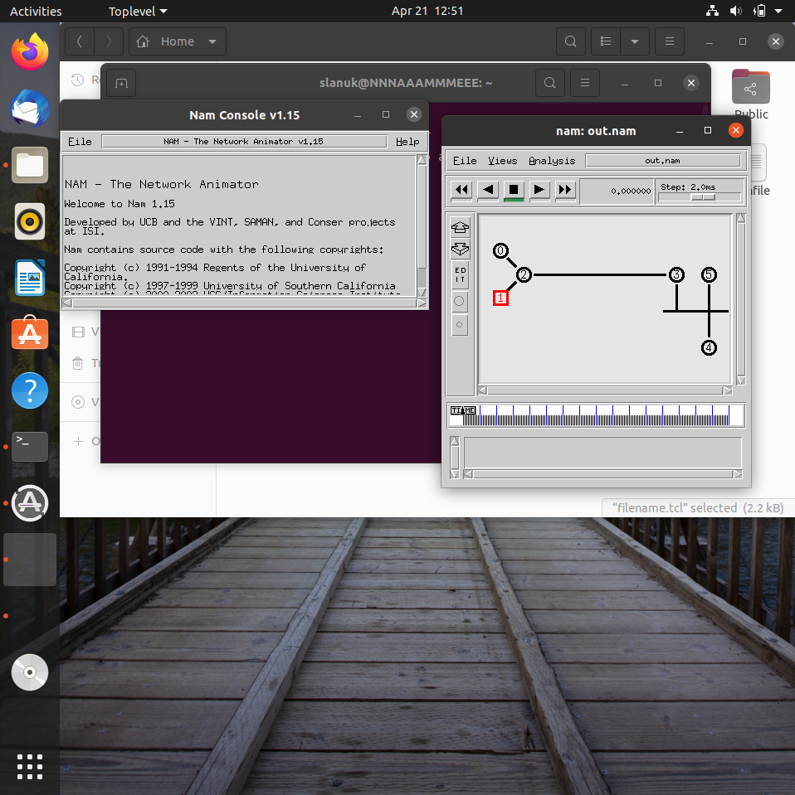

**EXPERIMENT 11**

**Aim:** Implementation of various MAC protocol.

**Multiple Access Control (MAC) Protocols**

Multiple access protocols are a set of protocols operating in the Medium Access Control sublayer (MAC sublayer) of the Open Systems Interconnection (OSI) model. These protocols allow a number of nodes or users to access a shared network channel.

Multiple access protocols can be broadly classified into three categories – random access protocols, controlled access protocols and channelization protocols.

**CSMA/CD**

It defines how network devices respond when two devices attempt to use a data channel simultaneously and encounter a data collision.

ALGORITHM:

1. Create a simulator object
2. Define different colors for different data flows
3. Open a nam trace file and define finish procedure then close the trace file, and execute nam on trace file.
4. Create six nodes that forms a network numbered from 0 to 5
5. Create duplex links between the nodes and add Orientation to the nodes for setting a LAN topology
6. Setup TCP Connection between n(0) and n(4)
7. Apply FTP Traffic over TCP
8. Setup UDP Connection between n(1) and n(5)
9. Apply CBR Traffic over UDP.
10. Apply CSMA/CA and CSMA/CD mechanisms and study their performance
11. Schedule events and run the program.

**Code:**

*#csma.tcl*

*set ns [new Simulator]*

*#Define different colors for data flows (for nam)*

*$ns color 1 Blue*

*$ns color 2 red*

*#Open the Trace files*

*set file1 [open out.tr w]*

*set winfile [open Winfile w]*

*$ns trace-all $file1*

*#Open the NAM trace file*

*set file2 [open out.nam w]*

*$ns namtrace-all $file2*

*#Define a 'finish' procedure*

*proc finish {} {*

*global ns file1 file2*

*$ns flush-trace*

*close $file1*

*close $file2*

*exec nam out.nam &*

*exit 0*

*}*

*#create six nodes*

*set n0 [$ns node]*

*set n1 [$ns node]*

*set n2 [$ns node]*

*set n3 [$ns node]*

*set n4 [$ns node]*

*set n5 [$ns node]*

*$n1 color Red*

*$n1 shape box*

*#create link between nodes*

*$ns duplex-link $n0 $n2 2Mb 10ms DropTail*

*$ns duplex-link $n1 $n2 2Mb 10ms DropTail*

*$ns simplex-link $n2 $n3 0.3Mb 100ms DropTail*

*$ns simplex-link $n3 $n2 0.3Mb 100ms DropTail*

*set lan [$ns newLan "$n3 $n4 $n5" 0.5Mb 40ms LL Queue/Droptail MAC/Csma/Ca*

*Channel]*

*#setup a TCP connection*

*set tcp [new Agent/TCP/Newreno]*

*$ns attach-agent $n0 $tcp*

*set sink [new Agent/TCPSink/DelAck]*

*$ns attach-agent $n4 $sink*

*$ns connect $tcp $sink*

*$tcp set fid_ 1*

*$tcp set window_ 8000*

*$tcp set packetSize_ 552*

*#setup FTP over TCP connection*

*set ftp [new Application/FTP]*

*$ftp attach-agent $tcp*

*$ftp set type_ FTP*

*#setup a UDp connection*

*set udp [new Agent/UDP]*

*$ns attach-agent $n1 $udp*

*set null [new Agent/Null]*

*$ns attach-agent $n5 $null*

*$ns connect $udp $null*

*$udp set fid_ 2*

*#setup a cbr over udp connexion*

*set cbr [new Application/Traffic/CBR]*

*$cbr attach-agent $udp*

*$cbr set type_ CBR*

*$cbr set packet_size_ 1000*

*$cbr set rate_ 0.01mb*

*$cbr set random_ false*

*$ns at 0.1 "$cbr start"*

*$ns at 1.0 "$ftp start"*

*$ns at 123.0 "$ftp stop"*

*$ns at 124.5 "$cbr stop"*

*#next procedure gets two arguments: the name of tcp source node will br called here*

*tcp*

*#and the name of output file*

*proc plotWindow {tcpSource file} {*

*global ns*

*set time 0.1*

*set now [$ns now]*

*set cwnd [$tcpSource set cwnd_]*

*set wnd [$tcpSource set window_]*

*puts $file "$now $cwnd"*

*$ns at [expr $now+$time] "plotWindow $tcpSource $file"}*

*$ns at 0.1 "plotWindow $tcp $winfile"*

*$ns at 5 "$ns trace-annotate \"packet drop\""*

*#PPP*

*$ns at 125.0 "finish"*

*$ns run*

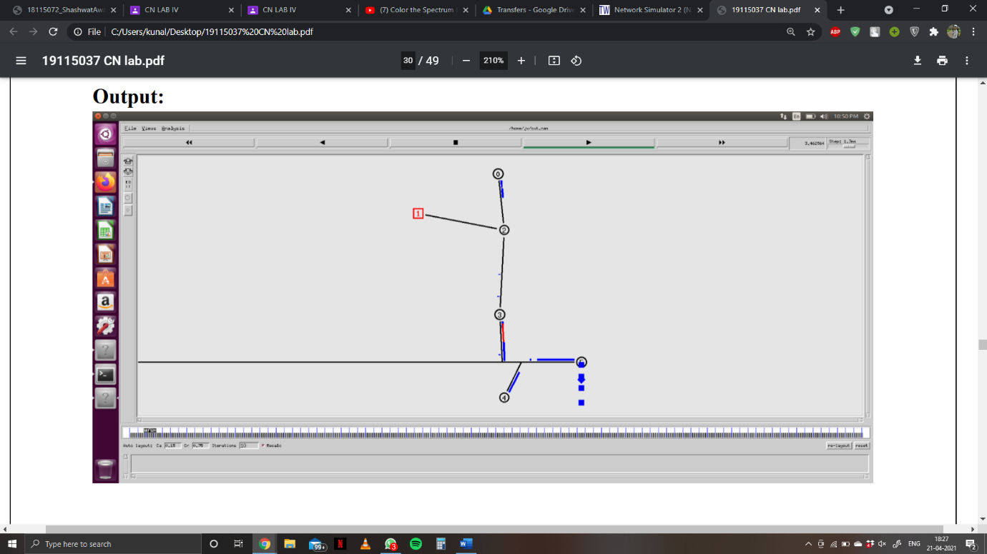**Output:**

**EXPERIMENT 12**

**Aim:** Measuring Network Performance: Network Performance Evaluation, Performance Evaluation Metrics.

**Network performance**

Network performance is defined by the overall quality of service provided by a network. This encompasses numerous parameters and metrics that must be analysed collectively to assess a given network.

Set of processes and tools that can be used to quantitatively and qualitatively assess network performance and provide actionable data to remediate any network performance issues.

**Why Measure Network Performance**

* Network Demands are Increasing so need for proper network performance.
* user satisfaction
* detect and diagnose performance issues
* to fully ensure network quality
* Interpretation from these performance metrics are equally important

**Performance Evaluation Metrics**

* The choice of metric would depend upon the purpose the network has been setup for.
* For example, TCP throughput is based on the application layer, whereas IP round trip time is based on the network layer.
* For example, a network supporting multimedia applications should have minimum delay and jitter. Packet loss might not be a critical issue for such network.
* However, packet loss might be a considerable factor for networks supporting textual data-oriented applications, say someone downloading by FTP.

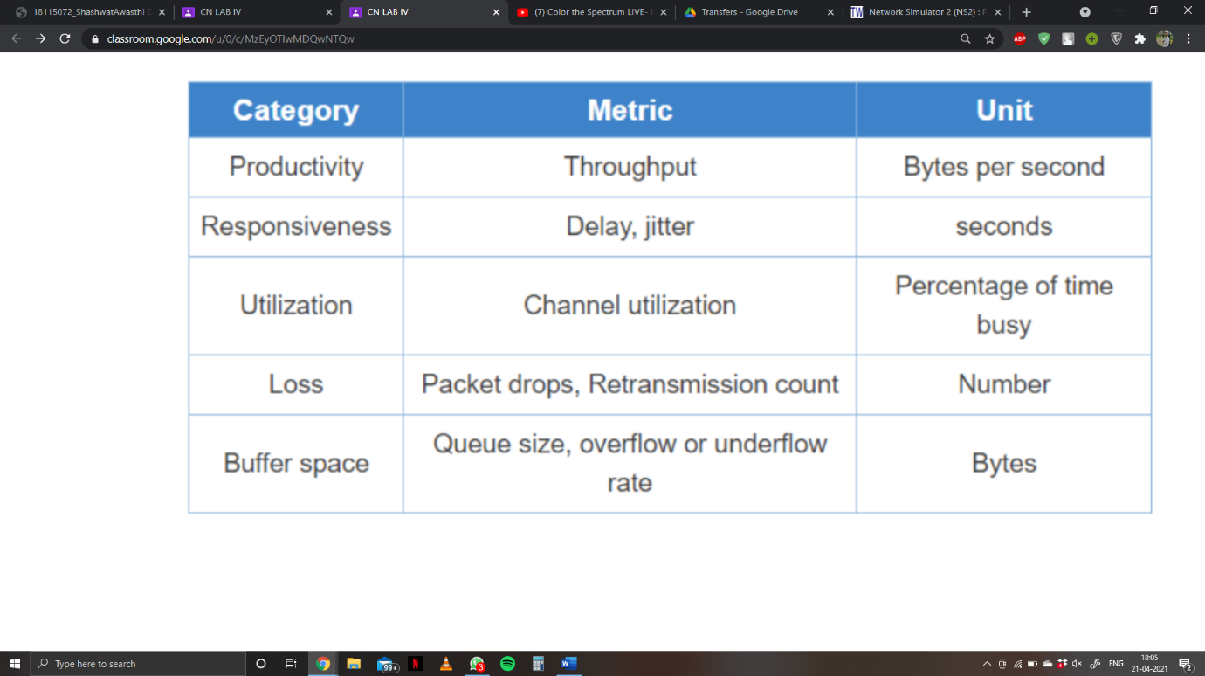The table below shows different metrics of evaluation, and categories they are appropriate for

It might not be always possible or feasible to obtain best performance from a network due to various factors like high cost, complexity, compatibility. In such cases one would like to obtain optimum performance by balancing different factors.

Following are some of the performance measurement metrics:

* Latency: It can take a long time for a packet to be delivered across intervening networks. In reliable protocols where a receiver acknowledges delivery of each chunk of data, it is possible to measure this as round-trip time.
* Packet loss: In some cases, intermediate devices in a network will lose packets. This may be due to errors, to overloading of the intermediate network, or to intentional discarding of traffic in order to enforce a particular service level.
* Retransmission: When packets are lost in a reliable network, they are retransmitted. This incurs two delays:
  + First, the delay from re-sending the data; and second, the delay resulting from waiting until the data is received in the correct order before forwarding it up the protocol stack.
  + Throughput: The amount of traffic a network can carry is measured as throughput, usually in terms such as kilobits per second. Throughput is analogous to the number of lanes on a highway, whereas latency is analogous to its speed limit.

**Parameters Affecting the Performance of Networks**

Different parameters can together or independently determine how well a network would perform.

A few such are mentioned below:

* Bandwidth: Its is the maximum data transfer rate which a link allows. It is expressed in bits per second(bps).
* Propagation Delay: It is the amount of time required to for a packet to travel from one node to another. If the propagation delay is high then throughput will be low i.e they are inversely proportional to each other.
* Queue type and queue size: The queue of a node is implemented as a part of a link whose input is that node to handle the overflow at the queue. But if the buffer capacity of the output queue is exceeded then the last packet arrived is dropped. We do set the buffer capacity by using queue size.

Latency = Propagation Time + Transmission Time + Queuing Time + Processing Delay

Propagation time = Distance / Propagation speed

**EXPERIMENT 13**

**Aim:** Performance Evaluation of routing Protocol.

The routing technique is needed for sending the data between the sensor nodes and the base stations, to establish communication. Routing protocols are the set of rules used by the routers to communicate between source & destination. Each protocol has its own algorithm to choose the best path.

* **Unicast routing :**

Unicast is a type of information transfer and it is used when there is a participation of single sender and single recipient.

* **Multicast routing :**

Multicasting has one/more senders and one/more recipients participate in data transfer traffic.

* Reactive protocol is a on demand process that means determine routes whenever needed while the proactive protocols maintain the route information prior.
* Performance metrics used for different routing protocols are Packet delivery ratio, energy consumption, throughput, average delay etc.

**Code:**

The following program shows how an XGraph can be used to plot the bandwidth of two nodes connected through the duplex wired link (An XGraph program draws a graph on an x-display given data read from either data file or standard input):

*#Create a simulator object*

*set ns [new Simulator]*

*#Open the output trace file*

*set f0 [open out0.tr w]*

*#Create 2 nodes*

*set n0 [$ns node]*

*set n1 [$ns node]*

*#Connect the nodes using duplex link*

*$ns duplex-link $n0 $n1 1Mb 100ms DropTail*

*#Define a 'finish' procedure*

*proc finish {} {*

*global f0*

*#Close the output files*

*close $f0*

*#Call xgraph to display the results*

*exec xgraph out0.tr -geometry 800x400 &*

*exit 0*

*}*

*#Define a procedure which periodically records the bandwidth received by the*

*proc record {} {*

*global sink0 f0*

*#Get an instance of the simulator*

*set ns [Simulator instance]*

*#Set the time after which the procedure should be called again*

*set time 0.5*

*#How many bytes have been received by the traffic sinks?*

*set bw0 [$sink0 set bytes_]*

*#Get the current time*

*set now [$ns now]*

*#Calculate the bandwidth (in MBit/s) and write it to the files*

*puts $f0 "$now [expr $bw0/$time*8/1000000]"*

*#Reset the bytes_ values on the traffic sinks*

*$sink0 set bytes_ 0*

*#Re-schedule the procedure*

*$ns at [expr $now+$time] "record"*

*}*

*#Create three traffic sinks and attach them to the node n4*

*set sink0 [new Agent/LossMonitor]*

*#Start logging the received bandwidth*

*$ns at 0.0 "record"*

*$ns at 60.0 "finish"*

*#Run the simulation$ns run*

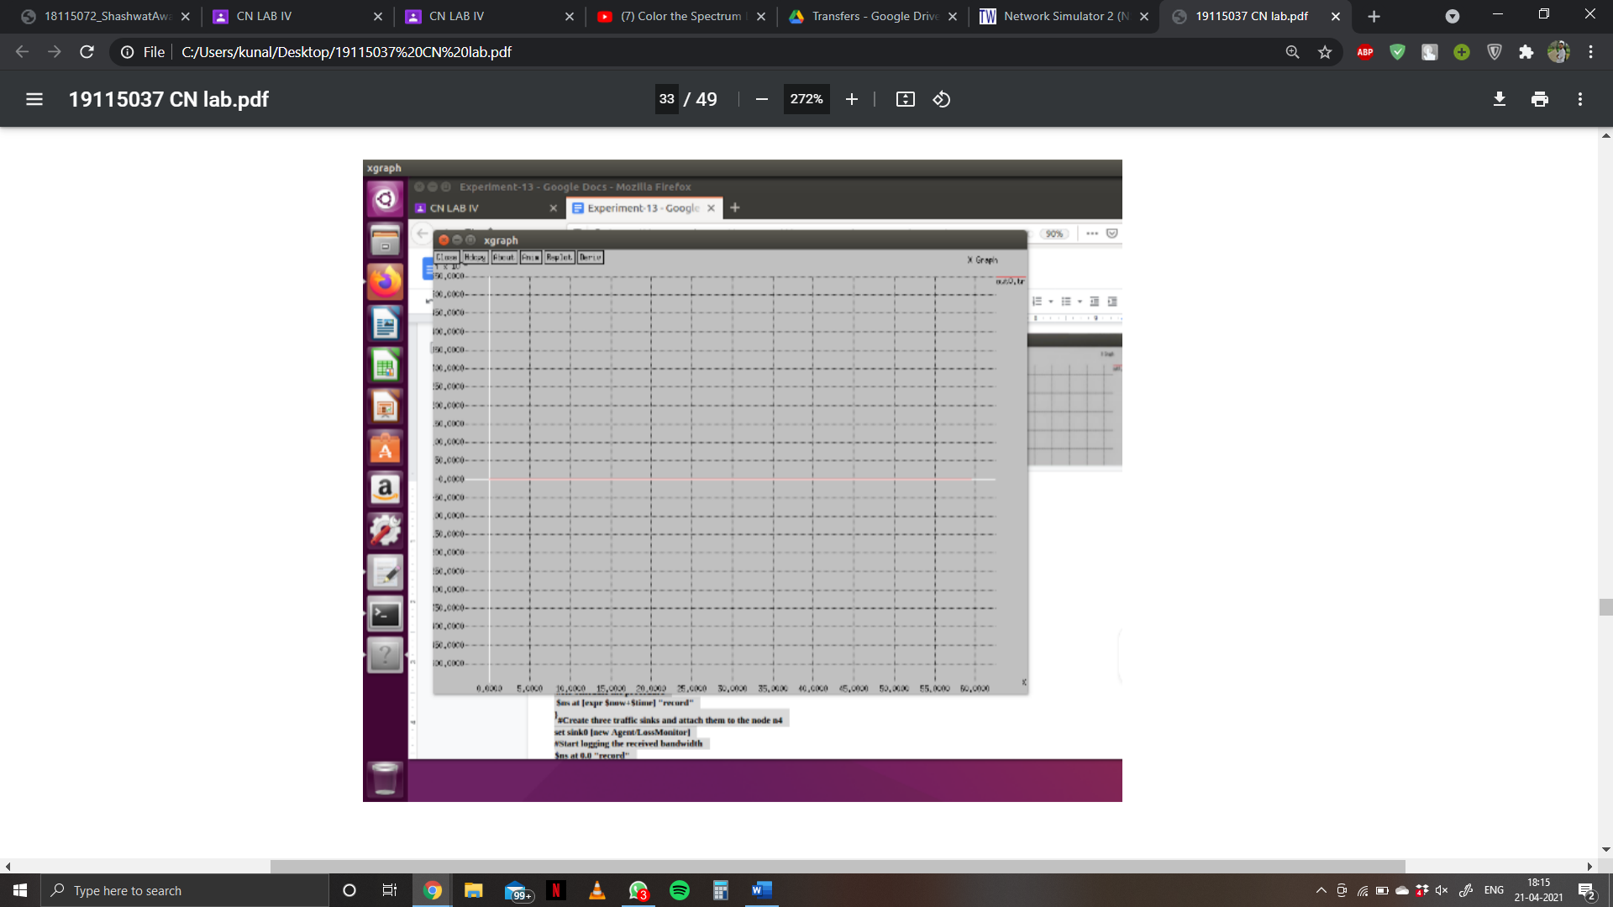**Output:**

**EXPERIMENT 14**

**Aim:** Parameter Affecting the Performance of Network, Performance Evaluation Technique, Network Performance Evaluation using NS-2/3.

**Parameters Affecting the Performance of Networks:**

Different parameters can together or independently determine how well a network would perform. A few such are mentioned below:

1. Bandwidth: Bandwidth is a measure of the amount of data that the medium can transfer over a given period of time. Each connected device requires bandwidth to be able to communicate. The bandwidth of the medium is shared between each connected device.
2. Latency: Network latency is a measure of how long it takes a message to travel from one device to another across a network. A network with low latency experiences few delays in transmission, whereas a high latency network experiences many delays.
3. Transmission errors: Inevitably there will be times when devices try to communicate with each other at the same time. Their signals collide with each other and the transmission fails. It is similar to when two people speak to each other simultaneously - neither person is able to clearly hear what the other person is saying.

**Network Performance Evaluation in NS2:**

Let’s discuss how to evaluate performance of a network by simulating it with ns2.

1. Design, develop and generate a network topology to be used within the simulation. This could be a wired network; in which case the topology remains fixed. However, for a wireless network with mobile nodes the topology would change with time, or randomly.
2. Once the topology has been generated, traffic source(sender) and destination(receiver) are fixed. Assign suitable traffic sources to the source nodes like tcp, udp and fpt, and traffic sinks like sink, null to the destination nodes.
3. Some of the parameters that can be used for comparative study of performance of the network are: link bandwidth, propagation delay, node queue type.

**EXPERIMENT 15**

**Aim:** Implement an Ethernet LAN using n nodes and set multiple traffic nodes and plot congestion window for different source / destination.

**Code:**

*set ns [new Simulator]*

*set tf [open lab7.tr w]*

*$ns trace-all $tf*

*set nf [open lab7.nam w]*

*$ns namtrace-all $nf*

*set n0 [$ns node]*

*set n1 [$ns node]*

*set n2 [$ns node]*

*set n3 [$ns node]*

*$ns make-lan "$n0 $n1 $n2 $n3" 10mb 10ms LL Queue/DropTail Mac/802_3*

*set tcp0 [new Agent/TCP]*

*$ns attach-agent $n0 $tcp0*

*set ftp0 [new Application/FTP]*

*$ftp0 attach-agent $tcp0*

*set sink3 [new Agent/TCPSink]*

*$ns attach-agent $n3 $sink3*

*$ns connect $tcp0 $sink3*

*set tcp2 [new Agent/TCP]*

*$ns attach-agent $n2 $tcp2*

*set ftp2 [new Application/FTP]*

*$ftp2 attach-agent $tcp2*

*set sink1 [new Agent/TCPSink]*

*$ns attach-agent $n1 $sink1*

*$ns connect $tcp2 $sink1*

*######To trace thecongestion window##########*

*set file1 [open file1.tr w]*

*$tcp0 attach $file1*

*$tcp0 trace cwnd_*

*$tcp0 set maxcwnd_ 1 0*

*set file2 [open file2.tr w]*

*$tcp2 attach $file2*

*$tcp2 trace cwnd_*

*proc finish { } {*

*global nf tf ns*

*$ns flush-trace*

*exec nam*

*lab7.nam &close $nf*

*close $tf*

*exit 0*

*}*

*$ns at 0.1 "$ftp0 start"*

*$ns at 1.5 "$ftp0 stop"*

*$ns at 2 "$ftp0 start"*

*$ns at 3 "$ftp0 stop"*

*$ns at 0.2 "$ftp2 start"*

*$ns at 2 "$ftp2 stop"*

*$ns at 2.5 "$ftp2 start"*

*$ns at 4 "$ftp2 stop"*

*$ns at 5.0 "finish"*

*$ns run*

***awk script***

*BEGIN {*

*}*

*{*

*if($6= ="cwnd_") /* don’t leave space after writing cwnd_ */ printf("%f\t%f\t\n",$1,$7); /\**

*you must put \n in printf */ }*

*END {*

*}*

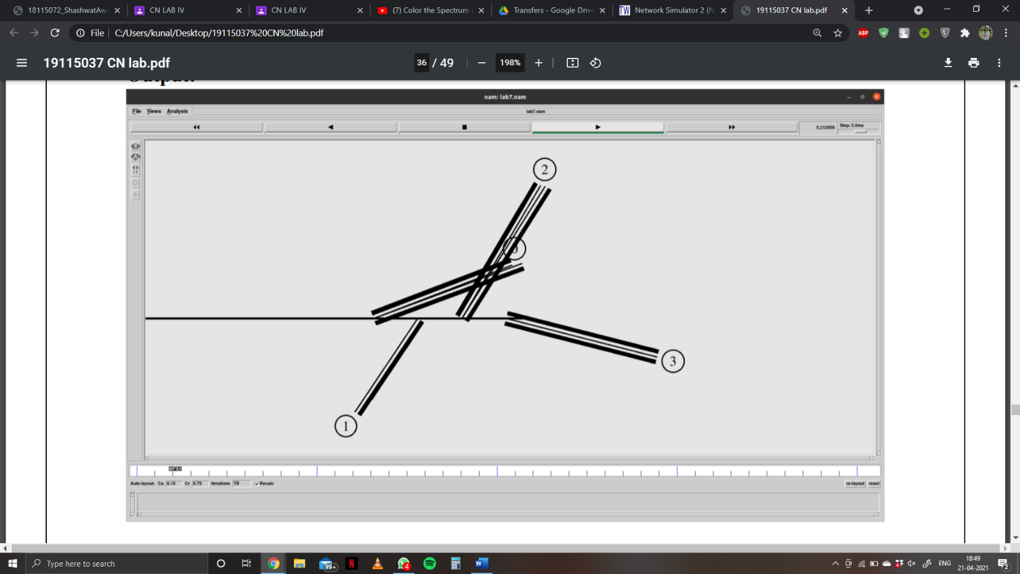**Output:**

**EXPERIMENT 16**

**Aim:** Implement simple ESS and with transmitting nodes in wire-less LAN by simulation and determine the performance with respect to transmission of packets.

**Code:**

*set ns [new Simulator]*

*set tf [open exp4.tr w]*

*$ns trace-all $tf*

*set topo [new Topography]*

*$topo load_flatgrid 1000 1000*

*set nf [open exp4.nam w]*

*$ns namtrace-all-wireless $nf 1000 1000*

*$ns node-config -adhocRouting DSDV *

*-llType LL *

*-macType Mac/802_11 *

*-ifqType Queue/DropTail *

*-ifqLen 50 *

*-phyType Phy/WirelessPhy *

*-channelType Channel/WirelessChannel *

*-propType Propagation/TwoRayGround *

*-antType Antenna/O mniAntenna *

*-topoInstance $topo *

*-agentTrace ON *

*-routerTrace ON*

*create-god 3*

*set n0 [$ns node]*

*set n1 [$ns node]*

*set n2 [$ns node]*

*$n0 label "tcp0"*

*$n1 label "sink1/tcp1"*

*$n2 label "sink2"*

*#The below code is used to give the initial node positions.*

*$n0 set X_ 50*

*$n0 set Y_ 50*

*$n0 set Z_ 0*

*$n1 set X_ 100*

*$n1 set Y_ 100*

*$n1 set Z_ 0*

*$n2 set X_ 600*

*$n2 set Y_ 600*

*$n2 set Z_ 0*

*$ns at 0.1 "$n0 setdest 50 50 15"*

*$ns at 0.1 "$n1 setdest 100 100 25"*

*$ns at 0.1 "$n2 setdest 600 600 25"*

*set tcp0 [new Agent/TCP]*

*$ns attach-agent $n0 $tcp0*

*set ftp0 [new Application/FTP]*

*$ftp0 attach-agent $tcp0*

*set sink1 [new Agent/TCPSink]*

*$ns attach-agent $n1 $sink1*

*$ns connect $tcp0 $sink1*

*set tcp1 [new Agent/TCP]*

*$ns attach-agent $n1 $tcp1*

*set ftp1 [new Application/FTP]*

*$ftp1 attach-agent $tcp1*

*set sink2 [new Agent/TCPSink]*

*$ns attach-agent $n2 $sink2*

*$ns connect $tcp1 $sink2*

*$ns at 5 "$ftp0 start"*

*$ns at 5 "$ftp1 start"*

*#The below code is used to provide the node movements.*

*$ns at 100 "$n1 setdest 550 550 15"*

*$ns at 190 "$n1 setdest 70 70 15"*

*proc finish {} {*

*global ns nf tf*

*$ns flush-trace*

*exec nam exp4.nam &*

*close $tf*

*exit 0*

*}*

*$ns at 250 "finish"*

*$ns run*

***Awk Script***

*BEGIN{*

*#include<stdio.h>*

*count1=0*

*count2=0*

*pack1=0*

*pack2=0*

*time1=0*

*time2=0*

*}*

*{*

*if($1=="r"&&$3=="_1_"&&$4 =="AGT")*

*{*

*count1++*

*pack1=pack1+$8*

*time1=$2*

*}*

*if($1=="r"&&$3=="_2_"&&$4 =="AGT")*

*{*

*count2++*

*pack2=pack2+$8*

*}*

*}*

*END{*

*time2=$2*

*printf("The Throughput from n0 to n1: %fMbps\n",*

*((count1*pack1*8)/(time1*1000000)))*

*printf("The Throughput from n1 to n2: %f*

*Mbps\n", ((count2* pack2 * 8) /(time2*1000000)))*

*}*

**Output:**

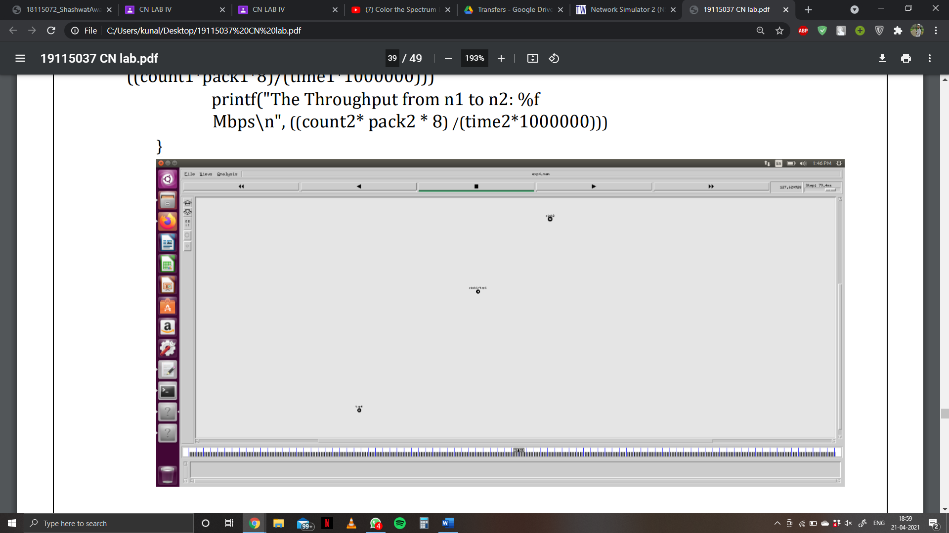

**EXPERIMENT 17**

**Aim:** Write a program for error detecting code using CRC-CCITT(16- bits)

**Code:**

*import java.io.*;*

*class Crc*

*{*

*public static void main(String args[]) throws IOException*

*{*

*BufferedReader br=new BufferedReader(new InputStreamReader(System.in));*

*System.out.println("Kunal Sachdeva");*

*System.out.println("Roll Number 19115045");*

*int[ ] data;*

*int[ ]div;*

*int[ ]divisor;*

*int[ ]rem;*

*int[ ] crc;*

*int data_bits, divisor_bits, tot_length;*

*System.out.println("Enter number of data bits : ");*

*data_bits=Integer.parseInt(br.readLine());*

*data=new int[data_bits];*

*System.out.println("Enter data bits : ");*

*for(int i=0; i<data_bits; i++)*

*data[i]=Integer.parseInt(br.readLine());*

*System.out.println("Enter number of bits in divisor : ");*

*divisor_bits=Integer.parseInt(br.readLine());*

*divisor=new int[divisor_bits];*

*System.out.println("Enter Divisor bits : ");*

*for(int i=0; i<divisor_bits; i++)*

*divisor[i]=Integer.parseInt(br.readLine());*

*tot_length=data_bits+divisor_bits;*

*div=new int[tot_length];*

*rem=new int[tot_length];*

*crc=new int[tot_length];*

*/*------------------ CRC GENERATION ------------------------*/*

*for(int i=0;i<data.length;i++)*

*div[i]=data[i];*

*System.out.print("Dividend (after appending 0's) are : ");*

*for(int i=0; i< div.length; i++)*

*System.out.print(div[i]);*

*System.out.println();*

*for(int j=0; j<div.length; j++){*

*rem[j] = div[j];*

*}*

*rem=divide(div, divisor, rem);*

*for(int i=0;i<div.length;i++)*

*//append dividend and ramainder*

*{*

*crc[i]=(div[i]^rem[i]);*

*}*

*System.out.println();*

*System.out.println("CRC code : ");*

*for(int i=0;i<crc.length;i++)*

*System.out.print(crc[i]);*

*/*-------------------ERROR DETECTION ----------------------*/*

*System.out.println();*

*System.out.println("Enter CRC code of "+tot_length+" bits : ");*

*for(int i=0; i<crc.length; i++)*

*crc[i]=Integer.parseInt(br.readLine());*

*for(int j=0; j<crc.length; j++){*

*rem[j] = crc[j];*

*}*

*rem=divide(crc, divisor, rem);*

*for(int i=0; i< rem.length; i++)*

*{*

*if(rem[i]!=0)*

*{*

*System.out.println("Error");*

*break;*

*}*

*if(i==rem.length-1)*

*System.out.println("No Error");*

*}*

*System.out.println("THANK YOU.........)");*

*}*

*static int[] divide(int div[],int divisor[], int rem[])*

*{*

*int cur=0;*

*while(true)*

*{*

*for(int i=0;i<divisor.length;i++)*

*rem[cur+i]=(rem[cur+i]^divisor[i]);*

*while(rem[cur]==0 && cur!=rem.length-1)*

*cur++;*

*if((rem.length-cur)<divisor.length)*

*break;*

*}*

*return rem;*

*}*

*}*

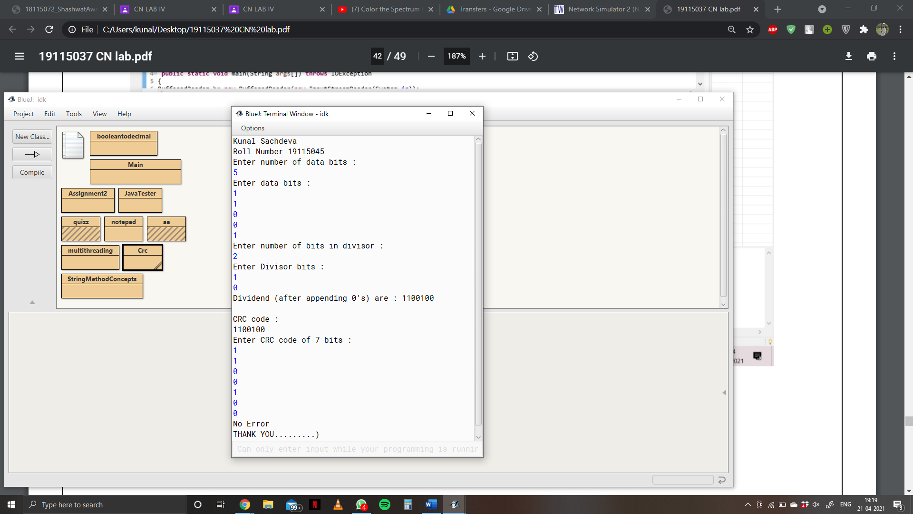**Output:**

**EXPERIMENT 18**

**Aim:** Write a program to find the shortest path between vertices using bellman-ford algorithm.

**Code:**

*import java.util.Scanner;*

*public class BellmanFord*

*{*

*private int D[];*

*private int num_ver;*

*public static final int MAX_VALUE = 999;*

*public BellmanFord(int num_ver)*

*{*

*this.num_ver = num_ver;*

*D = new int[num_ver + 1];*

*}*

*public void BellmanFordEvaluation(int source, int A[][])*

*{*

*for (int node = 1; node <= num_ver; node++)*

*{*

*D[node] = MAX_VALUE;*

*}*

*D[source] = 0;*

*for (int node = 1; node <= num_ver - 1; node++)*

*{*

*for (int sn = 1; sn <= num_ver; sn++)*

*{*

*for (int dn = 1; dn <= num_ver; dn++)*

*{*

*if (A[sn][dn] != MAX_VALUE)*

*{*

*if (D[dn] > D[sn]+ A[sn][dn])*

*D[dn] = D[sn] + A[sn][dn];*

*}*

*}*

*}*

*}*

*for (int sn = 1; sn <= num_ver; sn++)*

*{*

*for (int dn = 1; dn <= num_ver; dn++)*

*{*

*if (A[sn][dn] != MAX_VALUE)*

*{*

*if (D[dn] > D[sn]+ A[sn][dn])*

*System.out.println("The Graph contains negative egde cycle");*

*}*

*}*

*}*

*for (int vertex = 1; vertex <= num_ver; vertex++)*

*{*

*System.out.println("distance of source " + source + " to "+vertex + " is " +D[vertex]);*

*}*

*}*

*public static void main(String[ ] args)*

*{*

*System.out.println("Kunal Sachdeva");*

*System.out.println("Roll Number 19115045");*

*int num_ver= 0;*

*int source;*

*Scanner scanner = new Scanner(System.in);*

*System.out.println("Enter the number of vertices");*

*num_ver = scanner.nextInt();*

*int A[][] = new int[num_ver + 1][num_ver + 1];*

*System.out.println("Enter the adjacency matrix");*

*for (int sn = 1; sn <= num_ver; sn++)*

*{*

*for (int dn = 1; dn <= num_ver; dn++)*

*{*

*A[sn][dn] =*

*scanner.nextInt();*

*if (sn ==dn)*

*{*

*A[sn][dn] = 0;*

*continue;*

*}*

*if (A[sn][dn] == 0)*

*{*

*A[sn][dn] = MAX_VALUE;*

*}*

*}*

*}*

*System.out.println("Enter the source vertex");*

*source = scanner.nextInt();*

*BellmanFord b = new BellmanFord (num_ver);*

*b.BellmanFordEvaluation(source, A);*

*scanner.close();*

*}*

*}*

**Output:**

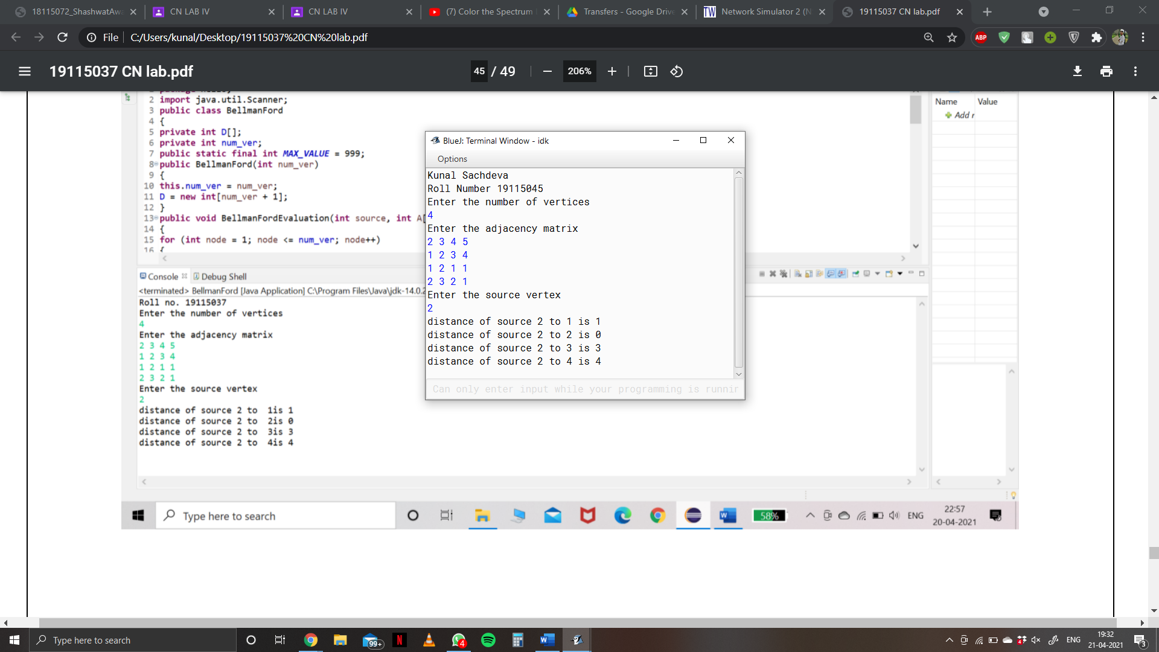

**EXPERIMENT 19**

**Aim:** Write a program for simple RSA algorithm to encrypt and decrypt the data.

**Code:**

*package hello;*

*import java.util.*;*

*import java.util.Scanner;*

*class h{*

*public static void main(String arg[]){*

*Scanner in=new Scanner(System.in);*

*System.out.println("Kunal Sachdeva");*

*System.out.println("Roll Number 19115045");*

*long p,q,d,z,e,n,c;*

*int choice;*

*System.out.println("Enter two distinct prime numbers");*

*p=in.nextLong();*

*q=in.nextLong();*

*n=p*q;*

*z=(p-1)*(q-1);*

*System.out.println("Enter a value for d which is less than and relatively prime to "+z);*

*d=in.nextLong();*

*for(e=1;e<z;++e)*

*{*

*if(((e*d)%z)==1)*

*break;*

*}*

*System.out.println("p="+p+"\nq="+q+"\nn="+n+"\nz="+z+"\nd="+d+"\ne="+e);*

*do{*

*System.out.println("1.Encription \n2.Decription\n3.Exit");*

*System.out.println("choose an option");*

*choice = in.nextInt();*

*switch(choice){*

*case 1:System.out.println("Enter a plain text");*

*String s = in.next();*

*System.out.println("Plain Text" +"\t" + "Cipher Text");*

*for(int i = 0; i < s.length(); i++){*

*long pl = (int) s.charAt(i);*

*c = modexp(pl,e,n);*

*System.out.println(s.charAt(i)+"\t\t" + c);*

*}*

*break;*

*case 2: System.out.println("Enter a cipher text (0 to stop input)");*

*long [] ci = new long[50];*

*int j =0;*

*do{*

*ci[j] = in.nextLong();*

*}while(ci[j++] != 0);*

*System.out.println("Cipher Text" +"\t" + "Plain Text");*

*for(int i = 0; i < j-1; i++){*

*long pl = modexp(ci[i],d,n);*

*System.out.println(ci[i]+"\t\t" + (char) pl);*

*}*

*break;*

*case 3: System.out.println("Program Terminated");*

*System.exit(0);*

*}*

*}while(choice != 3);*

*}*

*static long modexp(long a,long x,long n)*

*{long r=1;*

*while(x>0)*

*{*

*if(x%2==1){*

*r=(r*a)%n;*

*}*

*a=(a*a)%n;*

*x/=2;*

*}*

*return(r);*

*}*

*}*

**Output:**

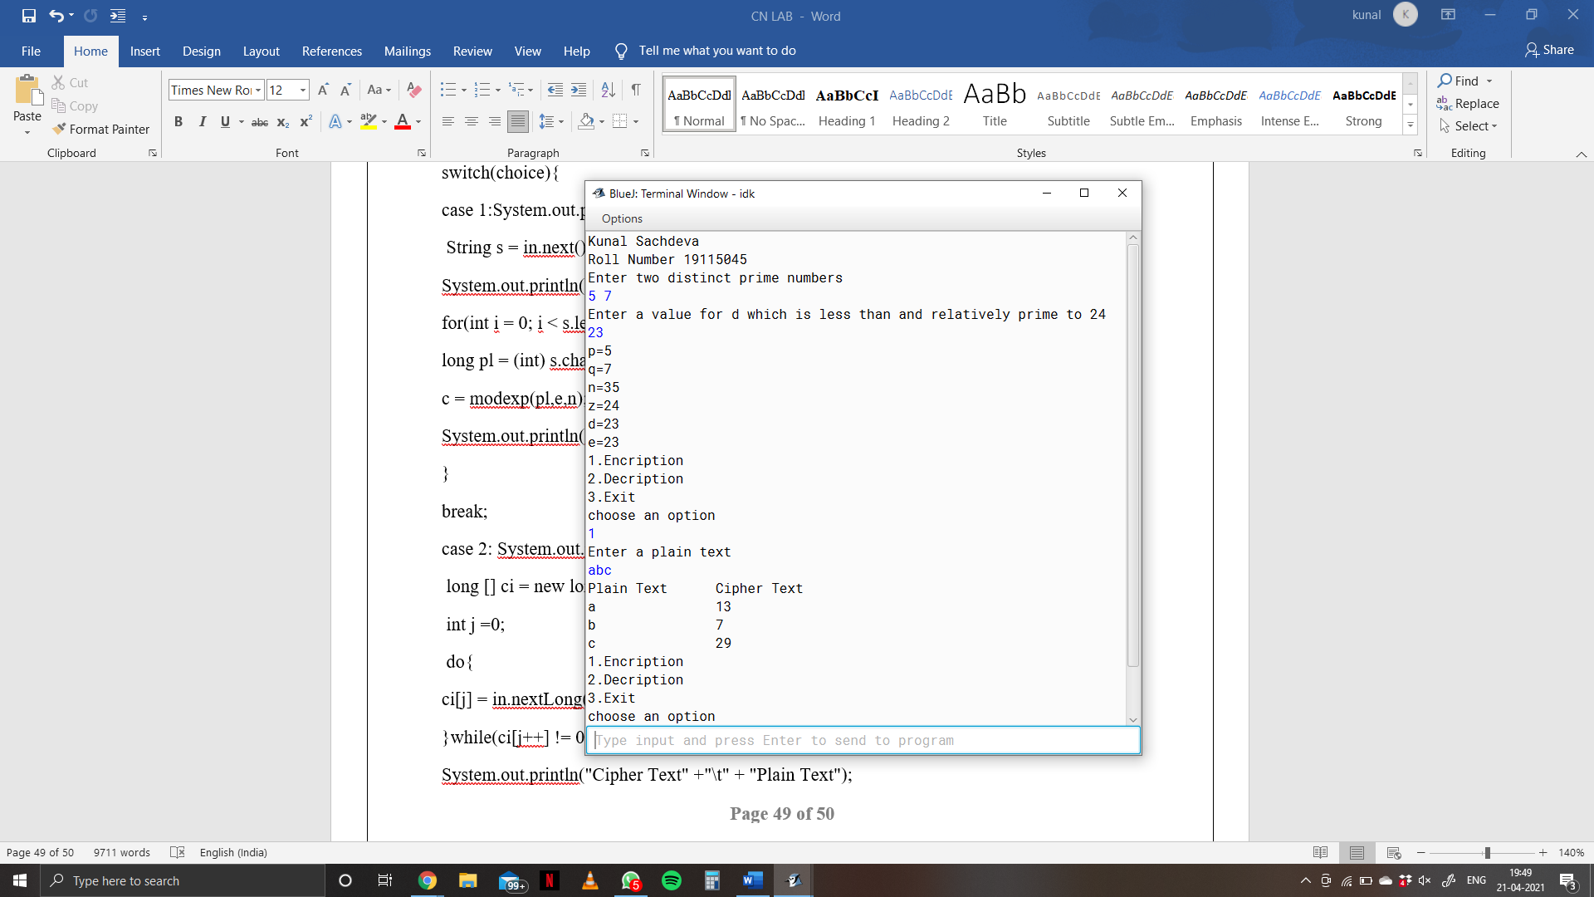

**EXPERIMENT 20**

**Aim:** Write a program for congestion control using leaky bucket algorithm.

**Code:**

*package hello;*

*import java.io.*;*

*import java.util.*;*

*class Queue*

*{*

*int q[],f=0,r=0,size;*

*void insert(int n)*

*{*

*Scanner in = new Scanner(System.in);*

*q=new int[10];*

*for(int i=0;i<n;i++)*

*{*

*System.out.print("\nEnter " + i + " element: ");*

*int ele=in.nextInt();*

*if(r+1>10)*

*{*

*System.out.println("\nQueue is full \nLost Packet: "+ele);*

*break;*

*}*

*else*

*{*

*r++;*

*q[i]=ele;*

*}*

*}*

*}*

*void delete()*

*{*

*Scanner in = new Scanner(System.in);*

*Thread t=new Thread();*

*if(r==0)*

*System.out.print("\nQueue empty ");*

*else*

*{*

*for(int i=f;i<r;i++)*

*{*

*try*

*{*

*t.sleep(1000);*

*}*

*catch(Exception e){}*

*System.out.print("\nLeaked Packet: "+q[i]); f++;*

*}*

*}*

*System.out.println();*

*}*

*}*

*class practical extends Thread*

*{*

*public static void main(String ar[]) throws Exception {*

*Queue q=new Queue();*

*Scanner src =new Scanner(System.in);*

*System.out.println("\nEnter the packets to be sent:");int size=src.nextInt();*

*q.insert(size);*

*q.delete();*

*}*

*}*